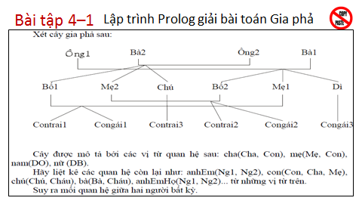

domains

s = symbol

predicates

Dad(s, s) % Dad(Dad, Child)

Mom(s, s) % Mom(Mom, Child)

Sibling(s, s) % Sibling(Elder, Younger)

Child(s, s) % Child(Child, Parent)

Grandchild(s, s) % Grandchild(Grandchild, Grandparent)

Grandparent(s, s) % Grandparent(Grandparent, Grandchild)

Uncle(s, s) % Uncle(Uncle, s)

Aunt(s, s) % Aunt(Aunt, s)

Cousin(s, s)

Mate(s, s) % Mate(Husband, Wife)

Male(s)

Female(s)

RS(s, s, s)

clauses

Dad(grandfather1, dad2).

Dad(grandfather1, mom1).

Dad(grandfather1, aunt).

Dad(grandfather2, dad1).

Dad(grandfather2, mom2).

Dad(grandfather2, uncle).

Dad(dad1, boy1).

Dad(dad1, girl1).

Dad(dad2, boy2).

Dad(dad2, girl2).

Dad(uncle, boy3).

Mom(grandmother1, dad2).

Mom(grandmother1, mom1).

Mom(grandmother1, aunt).

Mom(grandmother2, dad1).

Mom(grandmother2, mom2).

Mom(grandmother2, uncle).

Mom(mom1, boy1).

Mom(mom1, girl1).

Mom(mom2, boy2).

Mom(mom2, girl2).

Mom(aunt, girl3).

Male(grandfather1).

Male(grandfather2).

Male(dad1).

Male(dad2).

Male(uncle).

Male(boy1).

Male(boy2).

Male(boy3).

Female(grandmother1).

Female(grandmother2).

Female(mom1).

Female(mom2).

Female(aunt).

Female(girl1).

Female(girl2).

Female(girl3).

% Quan he khac

Child(X, Y) :- Dad(Y, X); Mom(Y, X).

Mate(X, Y) :- Child(Z, X), Child(Z, Y).

Sibling(X, Y) :- Dad(A, X), Dad(A, Y), Mom(B, X), Mom(B, Y), not(X = Y).

Grandparent(X, Y) :- Dad(X, Z), Dad(Z, Y); Mom(X, Z), Mom(Z, Y);

Dad(X, Z), Mom(Z, Y); Mom(X, Z), Dad(Z, Y).

Grandchild(X, Y) :- Grandparent(Y, X).

Uncle(X, Y) :- Male(X), Sibling(X, Z), Dad(Z, Y);

Male(X), Sibling(X, Z), Mom(Z, Y).

Aunt(X, Y) :- Female(X), Sibling(X, Z), Dad(Z, Y);

Female(X), Sibling(X, Z), Mom(Z, Y).

Cousin(X, Y) :- Uncle(Z, X), Dad(Z, Y); Aunt(Z, X), Mom(Z, Y);

Uncle(Z, Y), Dad(Z, X); Aunt(Z, Y), Mom(Z, X).

RS(X, Y, R) :-

Dad(X, Y), R = "Dad-Child";

Mom(X, Y), R = "Mom-Child";

Child(X, Y), R = "Child-Parent";

Grandparent(X, Y), R = "Grandparent-Grandchild";

Grandchild(X, Y), R = "Grandchild-Grandparent";

Uncle(X, Y), R = "Uncle-ChildOfSibling";

Aunt(X, Y), R = "Aunt-ChildOfSibling";

Sibling(X, Y), R = "Sibling";

Cousin(X, y), R = "Cousin";

Mate(X, Y), R = "HusbandAndWife".